**New Burdens Funding – Justification Led Bid Information Sheet**

**Summary**

This at-a-glance guide is designed to minimise knowledge gaps and encourage confidence for those in the sector submitting a Justification Led Bid (JLB). The required forms and a breakdown of what is considered eligible expenditure have been provided alongside this information sheet.

To submit a successful JLB you must send the following to [elections@communities.gov.uk](mailto:elections@communities.gov.uk) by **14/09/2025**:

1. **Completed ‘JLB 2025 New Burdens’ Excel sheet**.
2. **Signed ‘JLB 2025 - Grant Claim Form’ document.**

**Timeline**

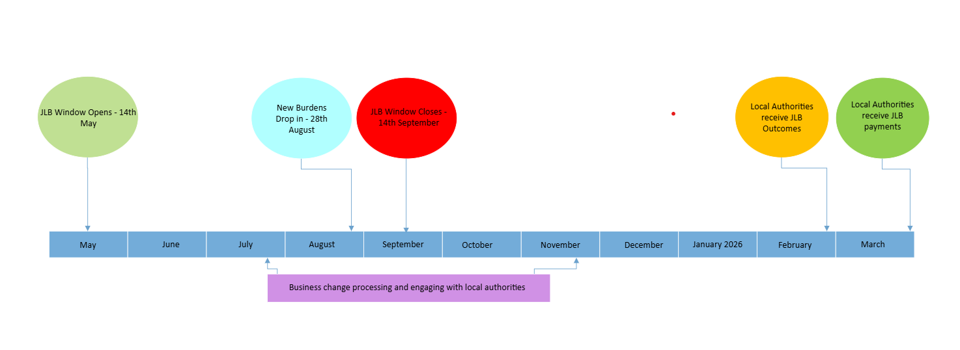

**JLB Top Tips**

* Provide a clear evidence base as to why additional staff have been hired (e.g. data on the number of VACs received in the LA, number of postal voters, etc).
* Provide a list of quotes and considerations for each costline when setting out your options. It is important to justify that when making purchasing decisions, the best value for money option was selected.
* Provide demographic data and details of specific local challenges to support any underlying cost lines where possible.
* Include only retrospective new burden costs.
* Reference engagement made with MHCLG prior to incurring significant costs where applicable.
* ***The more conclusive your justification is, the less likely the need for further contact from us during the approval phase.***